 Contact:

FOR IMMEDIATE RELEASE

Karen Steele

(616) 676-9185 x100

ksteele@bakerpublishinggroup.com

**Irene Hannon Celebrates 50th Novel with Return to Oregon Coast in**

Sea Rose Lane

**“One Great Storyteller”**

—Debbie Macomber, *NYT* bestselling author

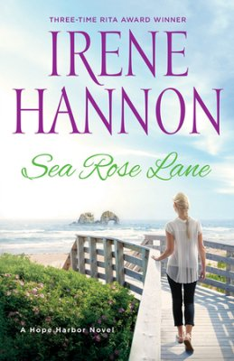**ADA, Mich.—**In her much-anticipated new book, *Sea Rose Lane*, award-winning author Irene Hannon takes readers back to the charming fictional town of Hope Harbor on the scenic Oregon coast. Her fascinating characters, touching romance, and stunning coastal setting combine in an unforgettable summer read. Fans of her earlier *Hope Harbor* have been anxiously awaiting a return to the charming locale, and *Sea Rose Lane* delivers all the romance and adventure they’ve come to appreciate from a Hannon novel.

In *Sea Rose Lane*, out-of-work attorney Eric Nash heads back to the town where he grew up—only to discover that his childhood home is being transformed into a bed-and-breakfast. Instead of plotting his next career move in peace, he’s constantly distracted by noise, chaos—and BJ Stevens, the attractive but prickly blonde architect and construction chief who’s invaded the house with her motley crew. As for BJ, her client’s son may be handsome, but after a disastrous romance, dating isn’t high on her agenda. Yet when they join forces to create a program for Hope Harbor seniors, might they also find healing, hope, and a new beginning themselves?

In *Sea Rose Lane*, her fiftieth novel, Irene Hannon draws on her impressive imagination and craft to take readers home to Hope Harbor—where hearts heal . . . and love blooms. Readers can look forward to more time on the Oregon Coast when the next book in the series, *Sandpiper Cove*, is released in the summer of 2017.

**Irene Hannon** is the bestselling author of more than fifty novels, including *One Perfect Spring* and *Hope Harbor*, as well as the Private Justice and Men of Valor series. Her books have been honored with three coveted RITA Awards from Romance Writers of America, two Carol Awards, three HOLT Medallions, a Daphne du Maurier Award, a Retailers’ Choice Award, two Retailers’ Choice Awards from *RT Book Reviews* magazine, two Booksellers’ Best Awards, and a National Readers’ Choice Award. In 2014, she was inducted into Romance Writers of America’s Hall of Fame as only the sixteenth member in the thirty-five-year history of the organization. Hannon lives in Missouri. Learn more at www.irenehannon.com.

**Revell**, a division of Baker Publishing Group, publishes books that help bring the Christian faith to everyday life. Whether through fiction, Christian living, self-help, marriage, family, or youth books, each Revell publication reflects relevance, integrity, and excellence. For more information, please visit [www.revellbooks.com](http://www.revellbooks.com).

###