 Contact:

FOR IMMEDIATE RELEASE

Karen Steele

(616) 676-9185 x100

ksteele@bakerpublishinggroup.com

**Sarah Sundin Explores the Dangers of Prejudice and Preconceptions in New WWII Mystery**

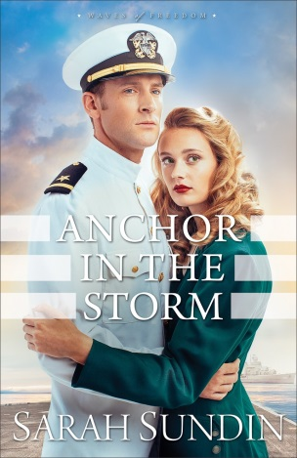Male and female stereotypes have always existed. World War II brought major changes to the status quo in America as necessity challenged traditional male/female roles and opportunities. **Sarah Sundin** delves into these dynamics in the second installment in her Waves of Freedom series, ***Anchor in the Storm***. As the needs of a nation brought millions of women into the workforce, some for the first time, ladies were suddenly finding new strengths and facing new tests, including Lillian Avery.

For plucky Lillian, America’s entry into World War II means a chance to prove herself as a pharmacist in Boston, and although her road isn’t easy, she has high hopes for success. Her boss isn’t thrilled about hiring a woman, and Lillian has a visible physical disability that causes some people to assume mistakenly she might be weak.

May 2016

$14.99; 400 pages

Paperback

9780800723439

$15.99; 336 pages

Paperback

9781441245458

Tensions on the job are just the beginning of Lillian’s difficulties. She also isn’t thrilled about the attention she’s receiving from society boy Ensign Archer Vandenberg. Arch himself is surprised to find himself drawn to Lillian. He’s typically skeptical of women; they’re usually more interested in his money than in him. The war has changed his life as well, as he hunts German U-boats along the East Coast on his destroyer. His efforts seem in vain as enemy submarines sink dozens of merchant ships.

Shaken by his battles at sea, Arch notices his men also struggle with their nerves—and with acute drowsiness. Could there be a link between their maladies and the large prescriptions for sedatives Lillian has filled? Arch and Lillian work together to find the answer, while Arch works to win Lillian’s trust and affection.

Sundin truly brings World War II to life in *Anchor in the Storm*, offering readers an intense experience they won’t soon forget. As always, Sundin had a Bible verse in mind as she wrote: Hebrews 6:18–19, which says, “We might have a strong consolation, who have fled for refuge to lay hold upon the hope set before us: Which hope we have as an anchor of the soul, both sure and stedfast.” Sundin hopes readers will learn along with Arch and Lillian to allow Christ to be their anchor no matter what shipwrecks they face in life.

Readers can keep their eyes peeled for the third book in the Waves of Freedom series, *When Tides Turn*, which will release spring 2017.



**Sarah Sundin** is the author of the Wings of the Nightingale series and the Wings of Glory series. Her novella “I’ll Be Home for Christmas” in *Where Treetops Glisten* was a 2015 finalist in the American Christian Fiction Writers Carol Awards. *On Distant Shores* was a finalist for the 2014 Golden Scroll Award from both the Advanced Writers and Speakers Association (AWSA) and the Christian Authors Network (CAN). In 2011, Sundin received the Writer of the Year Award at the Mount Hermon Christian Writers Conference. Her latest World War II series is Waves of Freedom, with *Through Waters Deep* and *Anchor in the Storm*.

A graduate of UC San Francisco School of Pharmacy, Sundin works on call as a hospital pharmacist. During WWII, her grandfather served as a pharmacist’s mate (medic) in the Navy, and her great-uncle flew with the US Eighth Air Force in England.

A mother of three, Sundin lives in California, where she teaches Sunday school and women’s Bible studies. She also enjoys speaking for community and writers’ groups.

**Revell**, a division of Baker Publishing Group, publishes books that help bring the Christian faith to everyday life. Whether through fiction, Christian living, self-help, marriage, family, or youth books, each Revell publication reflects relevance, integrity, and excellence. For more information, please visit [www.revellbooks.com](http://www.revellbooks.com).

###

**Praise for Sarah Sundin**

“Sundin’s latest is full of exciting intrigue, set right before the United States enters World War II. Sundin gives just the right amount of romance to balance out the drama.”

* *RT Book Reviews*, 4½ stars, for *Through Waters Deep*

“Readers will be struck by the thoughtfulness and care Sundin brings to every thread in this chilling story as they are swept up into exciting plot twists leading to a thrilling climax.”

* *Booklist*, starred review, for *Through Waters Deep*